2F 12 Appropriate Diagnostic Reference Levels (DRLs) in place

DRLs for digital and film based radiology will differ
Example of DRLs and guidance from the CDO is in separate attachment 2F 12i 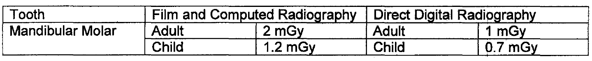
If you are in any doubt regarding patient dose settings you should conduct your RPA

