2F10 Documented QA system for employers written procedures and protocols ( in place and up to date)

Complete page 2 of the Employers written procedures
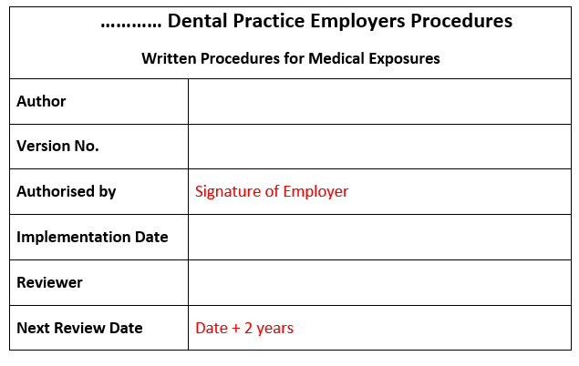
Ensure all pages have a footer with the practice name and version number
The protocols for exposure are not included in this document to ensure QA for the exposure protocols these should also include a footer with
Issue date | Version number | Authorised by | Author | Review date | Page no

